Board Manual 2018

Mission Statement
We share God’s love through intentional relationships for the restoration of a brokenhearted world.
The “We” is you, (donors, churches, friends, volunteers, community, and Victory staff).

Vision Statement
Every Life has Purpose!
Statement of Faith
We believe the Bible is the inspired, infallible, ultimately authoritative Word of God.
We believe there is one God, eternally existing as Father, Son, and Holy Spirit.
We believe that the Lord Jesus Christ is Deity; that He was born of a virgin; that we are redeemed by His atoning death through His shed blood; that He bodily resurrected and ascended into Heaven; and that He will come again in power and glory.
We believe that man is born with a fallen nature; that such nature can only be restored through the redemptive work of Jesus Christ; that the atonement through Christ is for the whole human race; and that whosoever repents and believes in the Lord Jesus Christ is justified, regenerated and saved from the dominion of sin.
We believe in the present ministry of the Holy Spirit, by whom Christ indwells each believer, enabling him to live a godly life of obedience to God’s Word.
Overview
Everett and Esther Cook founded the Springfield Victory Mission in 1976. The Mission today is a multi-service Christian organization that humbly reaches out to the poor and homeless in our community. Each day the organization commits and takes action to love our neighbors. A volunteer Board of Directors governs the Mission and a committed staff and management team oversee the day-to-day operations of the multiple programs and services. We strive to maintain a Board that promotes a culture and structure to meet the new generation of nonprofit standards. We see meeting these new standards as the best way to practice our mission and keep Victory Mission (VM) healthy. This manual outlines the key aspects of Board responsibilities and activities.

Board Responsibilities

&

Board Member Job Description

VM Roles and Responsibilities of Board

Ten Basic Responsibilities of Nonprofit Boards
1. Determine mission and purpose. It is the board's responsibility to create and review a statement of mission and purpose that articulates the organization's goals, means, and the
primary constituents served. The statement of mission should be a guide for planning, decision-making, initiatives and priority setting.

2. Select the chief executive. Boards must reach consensus on the chief executive's
responsibilities and undertake a careful search to find the most qualified individual for
the position. Prepare a comprehensive job description and determine compensation package and terms of employment.

3. Support the chief executive and review his or her performance. The board should ensure that the chief executive has the moral and professional support he or she needs to further the goals of the organization. A formal and informal performance review process is important to ensure annual goals and objectives are moving forward and real time feedback is relevant to the health of the organization.

4. Ensure effective planning. Boards must actively ensure and participate in planning, which should be in place both from an operational and strategic perspective. The board should encourage and facilitate a substantive planning process for a long range organization view, and assist in implementing and monitoring the plan's goals.

5. Monitor and strengthen programs and services. The board's responsibility is to
determine whether current and proposed programs and services are consistent with the organization's mission. The board must decide among competing priorities how to allocate resources. Monitoring programs and services for cost, quality and effectiveness is an important board role

6. Ensure adequate financial resources. One of the board's foremost responsibilities is to
secure adequate resources for the organization to fulfill its mission. The full board has a responsibility to fund raise.

7. Protect assets and provide proper financial oversight. The board assists in
developing and then approves the annual budget. Ensuring that proper financial controls are in place and monitoring occurs with the board’s regular review of financial statements.

8. Build and maintain a competent board. The board is responsible to articulate prerequisites for candidates, orient new members, and periodically and comprehensively evaluate the board‘s overall performance.

9. Ensure legal and ethical integrity. The board is ultimately responsible for adherence to
legal standards and ethical norms. The board ensures operational policies are maintained and followed.

10. Enhance the organization's public image. The board should clearly articulate the
organization's mission, accomplishments, and goals to garner public and community support.

Adopted & Adapted from: Source: Richard T. Ingram, Ten Basic Responsibilities of Nonprofit Boards, Second Edition (Board Source 2009).

Victory Mission Board of Director Job Description

Overview: Those who voluntarily serve, as a board member to the Victory Mission do so to offer their knowledge, skill, expertise, resources, passion, and compassion of Christ to the life-changing ministries offered by the Mission. The board member is in agreement with the organization’s mission and works as a board member to assist the community and staff to meet that mission.
Qualifications:
The board member is in agreement with the Statement of Faith of the Victory Mission.
A board member will:
- Profess to be born again John 3:3
- Have a personal ongoing, growing relationship with Jesus Christ - Ephesians 4:11
- Live out a lifestyle and attitude of service - Philippians 2:5-7
- Spend time in God’s word on a regular basis - 1 Peter 2:2
- Actively fulfilling the “Great Commission” - Matthew 28:19-20 & Acts 1:8
- Spend time in prayer - Philippians 4:6
- Puts God first before everything else - Mark 12:30
- Attends and is engaged in a local church - Acts 2: 42-47 & Hebrews 10:25
A board member is a person who exhibits integrity in their life and will serve the Victory Mission with integrity.
Duties and responsibilities:
As a board member of Springfield Victory Mission will read and uphold the Roles and Responsibilities that have been defined for the board as a whole.
As a board an individual serving on the board you agree to:
- Pray regularly for all aspects of the Mission staff, services, clients, and community
- Attend board meetings and participate in accordance with the board attendance policy
- Faithfully come to board meetings prepared by reviewing documents prior to the meeting time
- Serve on board subcommittees and take special assignments as requested
- Assist in identifying other community members who should serve on this board
- Attend VM special events, functions, fundraisers
- Avoid conflicts of interest and have no excess benefit expectation
- Commit to serve out term
- Give an annual personal contribution according to personal means and assist in get other donations and resources through personal influence with others (corporations, individuals, foundations, etc.)
- Serve the board with a spirit of willingness and enthusiasm
- Know the organization’s mission, purpose, goals, policies, programs, services, strengths and needs and assist in monitoring and reviewing each
- Follow the board policies and procedures
- Ask good questions and provide candid and constructive advice and comments

Committee Structure

Committee Responsibility

Board Officers

The Victory Mission Board
The Board will maintain a diverse membership who will bring specific expertise and experience to the board’s membership that will enhance the effectiveness of the board to govern the organization. Members shall serve three-year terms and can be renewed for two terms. This will ensure the organization’s historic perspective and also ensure added new perspective through a term rotation process. The board should maintain a membership of no less than 12 and no more than 15 members.
The board terms will be staggered to ensure the integrity of organizational continuity and collective shared understanding from year to year. At the completion of a members two three year terms the board member may remain active in the Mission organization as a committee member and may be considered for a new cycle of Board membership following the one year sabbatical from the Board.
The Board will meet on a regular basis to effectively be informed and be available for timely organizational decisions. Meetings will be at a minimum every other month on a standard meeting date to be determined in December of every year for the following calendar year to accommodate the current board member’s schedules. Currently, the board meets on the fourth Thursday of every month in 2018.

Board Officers
The board will have the following officers who will serve a defined term for each officer position.
Chairman of the Board – is a two-year term. The chairperson should have served on the executive committee a minimum of one year prior to assuming the chairman position. This officer will plan with the executive director and executive committee the board meeting agenda and preside over the meetings. The chairperson will ensure the activities of board development and board assessment are in place. Conduct or delegate the orientation sessions for new board members and ensures organized training sessions are in place for the entire board
Vice Chairman will have a one-year term and may assume this position after serving in another officer position or maybe appointed directly from the board membership into this office.
Secretary is a one-year term that can be repeated up to two terms. This secretary will support the documentation of meeting activity and board correspondence.
Treasurer is a one-year term that can be repeated up to three terms. This officer will work with staff to present the financials to the board in a meaningful informative manner. The treasurer will work with staff to prepare for the audit.

Executive Committee

The Executive Committee is comprised of the board officers and one at large committee chair that will rotate on to the Executive Committee each year. The executive committee will meet monthly and oversee the organization’s governing needs and prepare the agenda for the board meetings. They will give oversight to all aspects of the organization and the board committees.

The Executive Committee will serve as the Finance Committee. The Board Treasurer will lead the group to build an annual schedule/timeline to conduct the finance committee activities including parameters for the annual budget preparation, review of the budgets prepared by staff and ensuring a consistency between the budget and the organization’s plan. In the capacity of Finance Committee the Executive Committee will:
- Report to the board any financial irregularities, concerns, opportunities.
- Recommend financial guidelines to the board (such as to establish a reserve fund or to obtain a line of credit for a specified amount).
- Oversee short and long-term investments,
- Recommend selection of the auditor and work with the auditor.
- Oversee the audit process as needed by interviewing auditors, reviewing bids, recommending selection of an auditor to the board, receiving the auditor's report, meeting with the auditor, and responding to the auditor's recommendations.

The Executive Committee will appoint three board members each October to be the Nominating Committee. They will oversee the process of identifying new board members, using the approved board matrix format. The entire Board will be ask to make suggestions for potential new members. The Nominating Committee will follow the Board Member Recruitment Process as noted in the policy section of this manual. The nominating committee will also recommend board officers for each new year to be elected in December of each year.

The Executive Committee will annually in November appoint a minimum of two board members to serve with the Executive Director and Fund Development Director to be the Fund Development / Fundraising Committee. This committee will give oversight to the fund development plan and ensure it is put into action.

The Executive Committee will serve as a Personnel Committee as necessary; this includes review of employee grievances unresolved by the basic grievance policy that require an appeal. This will include the responsibility to do an annual review of salaries and positions for the successful operation of the organization.

Committee Duties & Annual Timeline

Board Nominating Committee – appointed each October
- To prepare priorities for board composition and recruitment
- To meet with prospective board members and recommend candidates to the board
- To recommend a slate of officers to the board

Fund Development and Fundraising Committee – appointed each November

This Committee works with staff to establish a comprehensive organization fund development and fundraising plan to present to the board annually with six-month updates. This committee meets four times each year.

Education /Programs & Services Committee

The Committee will have three Board members on this committee and will be led by the Vice Chairman of the Board. This committee gives oversight to the education, programs and services offered by Victory Mission. The committee develops and maintains an annual process to evaluate all education, programs and services including:
- To oversee new program development, and to monitor and assess existing programs
- To initiate and guide annual program evaluations
- To facilitate discussions about program priorities for the agency.

At least one board member from the Board will serve on the Community Advisory Committee (CAC) of Victory Trade School and will serve as a liaison to this board committee from the CAC.

Prayer & Church Relations Committee

The Prayer & Church Relations Committee is to forward the purpose of the mission by the power of prayer. This committee will have a minimum of two Board members serving on this committee. The committee will design and set regular times to pray for the work of the mission. It can operate as a virtual committee. The Chair of this committee organizes a team of prayer warriors to cover the VM with prayer in an ongoing disciplined approach and calls on the full board membership and the larger community of faith to participate in seeking divine guidance and provision.

Temporary Task Force & Committees
The Board can create a temporary task force or committee to address a special event, a specific issue, or a special need of the organization at which time it is deemed necessary or helpful. The combination of membership to each will be determined by the Board to appropriately meet the need.

Board Calendar

Annual Board Mile Marker Dates

Board Mile Marker Approximate Dates

- January 1st Fiscal year begins

- January Board meeting New Board members approved

- January Board meeting Budget approval

- February New Board Member orientation

- February Board Self Evaluation completed bi-annually odd
years

- February Evaluate Executive Director & establish Executive Director’s goals for next year based on organization’s performance and plans

- August
Annual Board planning August-- Conduct strategic planning bi-annual odd years

- October
Appoint Nominating Committee to recruit new board members
Fund Development Plan Submitted

- December
New Board Members selected approved in December or January

2018 Board Meeting Dates

&

Victory Mission Events

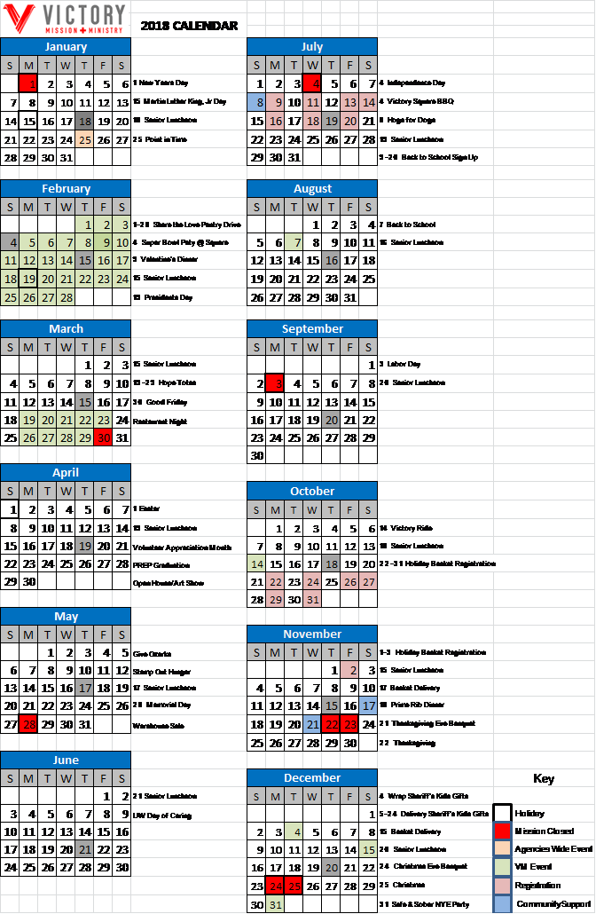

Board Policies

&

Procedures

Conflict of Interest Statement Policy

No member of the Board of Directors, or any of its Committees, shall derive any personal profit or gain, directly by reason of his or her participation with the Springfield Victory Mission. Each individual shall disclose to the organization any personal interest, which he or she may have in any matter pending before the organization and shall refrain from participation in any decision on such matter.
Any member of the Board, a Committee or Staff who is an officer, board member, a committee member, or staff member of a client organization or vendor of the Springfield Victory Mission shall identify his or her affiliation with such agency or agencies; further, in connection with any committee or board action specifically directed to that agency, s/he shall not participate in the decision affecting that agency and the decision must be made and/or ratified by the full board.
Any member of the Board, any Committee, Staff, and certain Consultants shall refrain from obtaining any lists of clients for personal or private solicitation purposes at any time during the term of their affiliation. Each board member, committee member, or employee of Springfield Victory Mission will sign the following statement annually.

Conflict of Interest Agreement Statement
At this time, I am a board member, committee member, or an employee of the Springfield Victory Mission.
This is to certify that I am not nor at any time during the past year have accepted as described below:
- Participation, directly or indirectly, in any arrangement, agreement, investment or other activity with any vendor, supplier, or other party doing business with the Springfield Victory Mission which has resulted or could result in personal benefit to me.
- Been a recipient, directly or indirectly, of any salary payments or loans or gifts of any kind or any free service or discounts or other fees from or on behalf of any person or organization engaged in any transaction with the Springfield Victory Mission.

If these statements are not fully accurate please provide an explanation as to the specifics of any variance:

Date: ____________________ Signature: ____________________________
Print Name: ____________________________

Board Meeting Attendance Policy

This policy is intended to support full contribution of all board members as a member of Springfield Victory Mission Board of Directors. All board members receive a copy of this official policy at the time of appointment and annually when the new meeting schedule is distributed.

The policy has been reviewed and authorized by the board.

Board attendance is expected at all regular meetings. If attendance cannot be fulfilled for a specific board meeting the member should notify the board chairman and executive director at the earliest knowledge they will miss the meeting.

A board-attendance problem occurs if any of the following conditions exist in regard to a board member's attendance to board meetings:

- The member has two un-notified absences in a row (“un-notified” means the member did not call ahead to contact in the organization before the upcoming meeting to indicate they would be gone from the upcoming meeting).

- The member has three notified absences in a row.

- The member misses one third of the total number of board meetings in a twelve-month period.

If a board-attendance problem exists regarding a member, the chair of the board will promptly contact the member to discuss the problem. The member’s response will promptly be shared by the chair of the board with the entire board at the next board meeting. In that meeting, the board will decide what actions to take regarding the board member’s future membership on the board.

If the board believes the member cannot contribute at the level the board needs from the member then the board will decide to terminate the board member’s membership. Termination will be conducted per this attendance policy expectation.

The board will promptly initiate a process to begin recruiting a new board member.

Executive Director Performance Review Policy & Process

Overview:
The Springfield Victory Mission’s Executive Director is appointed by the Board of Directors and answers to the Board for his or her performance. This position is foundational to the management of all of the operations of the Victory Mission. The mission/ purpose, culture and spirit of the organization is set by the Board and it is the expectation that the Executive Director will nurture and grow the mission/purpose, culture, and spirit. Monitoring the progress of the organization’s advancement to meet the annual goals and performance expectation is the board’s responsibility. The Board will follow the performance review policy to give clarity and direction annually to the Executive Director regarding his or her job performance expectations. The Board at any time throughout the year may and should address any performance issues that are problematic and detrimental to the agency and its mission.

Process:
- The Executive Director Job Description will outline the basic expectations of the job and will be reviewed annually in January by the Executive Committee to determine any updates necessary.
- Annually in January each board member will receive a short feedback survey from the chairman of the board regarding the Executive Director’s performance.
- This feedback will be reviewed by the Executive Committee for patterns or significant relevant responses and this information will be included in the performance appraisal feedback.
- The organization’s performance goals and the specific performance goals for the Executive Director will be determined annually after the end of the fiscal year. (by 2nd week in February). The Executive Committee with full Board approval will develop the performance goals for the Executive Director.
- The full Board will be presented the highlights of the performance appraisal prior to the Executive Committee presenting it to the Executive Director.
- The Executive Director may give feedback to the Executive Committee regarding the status of performance goals from his or her perspective and present these to the Executive Committee prior to the finalized appraisal presentation.
- Annually performance goals will be set in February and quarterly monitoring of progress will occur between the Board and the Executive Director.

Executive Director Victory Mission

Job Description

Job Title: Executive Director

Reports To: Board of Directors

Job Status: Full-time, regular – Exempt

Job Summary: Carries out the organizational plans and directives of the Board of Directors. Is responsible for the overall day-to-day management of all areas of Victory Mission.

Job Duties & Responsibilities:

Ensures that the Mission continues to perform its role as God’s servant in its local community

Assures that the Mission and its programs and services are consistently presented in strong, positive image to the local community by participating in public relations events and activities

Approves fundraising plans to support the Mission’s goals
- Provides leadership in developing program, organizational and financial plans with the Board of Directors and staff, and carries out plans and policies authorized by the board.

Attends all Board of Directors meetings and participate as an ex-officio member.

Provides the Board of Directors with information necessary to make competent decisions

Responsible for all financial agreements and contracts, including the borrowing of money, renting of real estate, obtaining insurance and purchasing major capital assets as required to carry out the business of the Mission (in accordance with the authorization given by the Board).
- Works with the staff, Finance Committee, and the Board in preparing a budget; prudently manages the Mission’s resources within those budget guidelines.

Maintains proper cash flow, reserves and operating funds to meet the needs of the Mission’s ongoing operations, facilities and staff.

Effectively manages the human resources of the Mission as to the number of staff, job responsibilities and compensation

Ensures that all staff are properly trained, evaluated and motivated to fulfill their job responsibilities so they may effectively carry out the Mission’s goals

Approves all changes to the Mission’s education and ministry programs

Fosters a nurturing Christian environment by balancing grace and truth while relying on the Spirit and Word of God.

Job Skills & Requirements:

Bachelor’s degree in business, ministry or related field or an equivalent number of years experience
- 8-10 years of increasingly responsible administrative experience, at least five of which shall have been in a supervisory capacity.

Effective leadership and organizational skills

Excellent communication skills

Experience with financial software & proficiency in MS Office/Google Apps

Strong commitment to serving Christ through leadership

Board Member Recruitment Process

- Solicit names of potential new members from Board & Ex director
(Early October)

- Nominating committee review names of potential new members and categorize by area of expertise and other board matrix categories and rank by greatest need for board compliment
(Before October 30th)

- Personal invitation to explore interest in VM Board participation & invitation to tour facilitates, recruitment talk hosted by Ex Director or designee

- November or December Nominating Committee reviews all interested candidates, obtains their completed questionnaire and develops the slate to be presented to the Board for approval

- Offer Board membership (preferable before January board meeting)

- Invite to the Board and arrange time for Board Orientation prior to the meeting if possible

List of all Board Members

and

Contact Information

Name & Address | Business | Fax | Home | Cell
Jason M. Hynson  3235 N. Fremont Ave.  Springfield, MO 65803 | 417-864-2216 | 417-831-9980 |  | 417-576-6929
 | Occupation | Executive Director, Springfield Victory Mission
 | Email | jhynson@victorymission.com
Executive Committee Joined 2016
Name & Address | Business | Fax | Home | Cell
Mr. Chris Harville  CHAIRMAN  4110 E. Bernie Lane  Springfield, MO 65803 | Email | CHarville@midmobank.com |  | 417-209-5348
 | Occupation | Mid Missouri Bank, Senior Vice President
 | Email | CHarville@midmobank.com
Executive Committee / Finance & Development Committee Joined ####
Name & Address | Business | Fax | Home | Cell
Mr. Craig Heidemann  Vice Chairman  1470 E. River Oak Drive  Springfield, MO 65803-8023 | 417-833-7751 | 417-326-2845 | 417-833-7751 | 417-224-4335
 | Occupation | Douglas, Haun & Heidemann, P.C., Attorney
 | Email | cheidemann@bolivarlaw.com
Executive Committee / Finance & Development Committee Joined ####
Name & Address | Business | Fax | Home | Cell
Rhonda Alexander  SECRETARY  1460 North Fenchurch Lane  Springfield, MO 65802 | 417-829-8270 |  | 417-839-5095
 |  | The Great Game of Business, Coaching Manager
 | Email | ralexander@ggob.com
Executive Committee and Finance Committee/ Joined 2016
Name & Address | Business | Fax | Home | Cell
Brad Brotherton  TREASURER  974 West Sycamore Avenue  Springfield, MO 65810 | 417-865-8701 |  | 417-496-3643
 | Occupation | Partner, BKD, LLP
 | Email | bbrotherton@bkd.com
Joined 2016 – Finance Committee, CAC

name & Address |  | Business |  |  |  |  | Fax
Name & Address | Business |  |  | Fax |  |  |  |  | Home |  | Cell
Mr. Dean Quillin  3859 Knollwood Drive  Ozark MO 65721 |  |  |  |  |  |  |  |  | 417-771-5569
 | Occupation |  |  | Retired |  |  |  |  |  |  |  |  |  | Retired
 | Email |  |  | ddquillin@att.net |  |  |  |  |  |  |  |  |  | ddquillin@att.net
Community Relations
Name & Address |  | Business |  |  | Fax |  |  |  | Home |  | Cell
Tony Turner  4627 South LaFontaine  Springfield, MO 65810 |  |  |  |  |  |  |  |  |  |  | 417-889-9447
 |  | Occupation |  |  | North Bridge Church, Lead Pastor
 |  | Email |  |  | tturner@mynorthbridge.org
Joined 2015 – CAC, Development Committee, Building
Name & Address |  | Business |  |  | Fax |  |  |  | Home |  | Cell
Rita Gurian  5043 South Glenhaven Avenue  Springfield, MO 65804 |  |  |  |  |  |  |  |  | 417-881-8656 |  | 417-848-7004
 |  | Occupation |  |  | Retired – 25 yrs @ CoxHealth Community Advocate & Volunteer
 |  | Email |  |  | Gurian.rita@gmail.com
Joined 2015 – Board Development Chair, Program/Ministries, CAC
Name & Address |  | Business |  |  | Fax |  |  |  | Home |  | Cell
Charles Greenaway  1006 Cobblefield Way  Ozark, MO 65721 |  | 417-581-5433 |  |  |  |  |  |  |  |  | 662-242-4640
 |  | Occupation |  |  | James River Church, Community Care Pastor
 |  | Email |  |  | chuck.greenaway@jamesriver.org
Joined 2016 – Board Development Committee, Community Relations
Name & Address |  | Business |  |  | Fax |  | Home |  |  |  | Cell
Susan Highley |  |  |  |  |  |  |  |  |  |  | 417-894-8328
 |  | Occupation |  |  | Performance Foods
 |  | Email |  |  | Susan.Highley@pfgc.com
Joined 2016 – Development Committee, Program/Ministries, CAC
Name & Address |  |  | Business |  |  | Fax |  | Home |  | Cell
Joe Peck  1450 East Bennett  Springfield, MO 65804 |  |  | 417-888-4402 |  |  |  |  |  |  | 417-827-5454
 |  |  | Occupation |  |  | Great Southern Bank
 |  |  | Email |  |  | joepeck0591@gmail.com
Joined February 2017 – Finance Committee
Name & Address |  |  | Business |  |  | Fax |  | Home |  | Cell
Name & Address |  |  | Business |  |  | Fax |  | Home |  | Cell
David Embree  4420 East Valley Road  Springfield, MO 65809 |  |  | 417-862-8080 |  |  |  |  | 417-886-1847 |  | 417-861-29995
 |  |  | Occupation |  |  | Director, Christian Campus Ministry, MSU
 |  |  | Email |  |  | DEmbree@MissouriState.edu
Joined February 2017 – CAC, Community Relations
Name & Address |  |  | Business |  |  | Fax |  | Home |  | Cell
Kim Hammons  2105 North Citation Avenue  Springfield, MO 65802 |  |  |  |  |  |  |  | 417-350-1077 |  | 417-844-9661
 |  |  | Occupation
 |  |  | Email |  |  | gintwkim@yahoo.com
Joined March 2017 – Programs/Ministries
Name & Address |  |  | Business |  |  | Fax |  | Home |  | Cell
Brandon Dake  Dake & Wells Architecture  134 Park Central Square Suite 300  Springfield, MO |  |  | 417.831.9904 |  |  |  |  |  |  | 417-459-3500
 |  |  | Occupation |  |  | Architect/Partner; Dake & Wells Architecture
 |  |  | Email |  |  | bdake@dake-wells.com

Organization Chart of

Victory Mission + Ministry

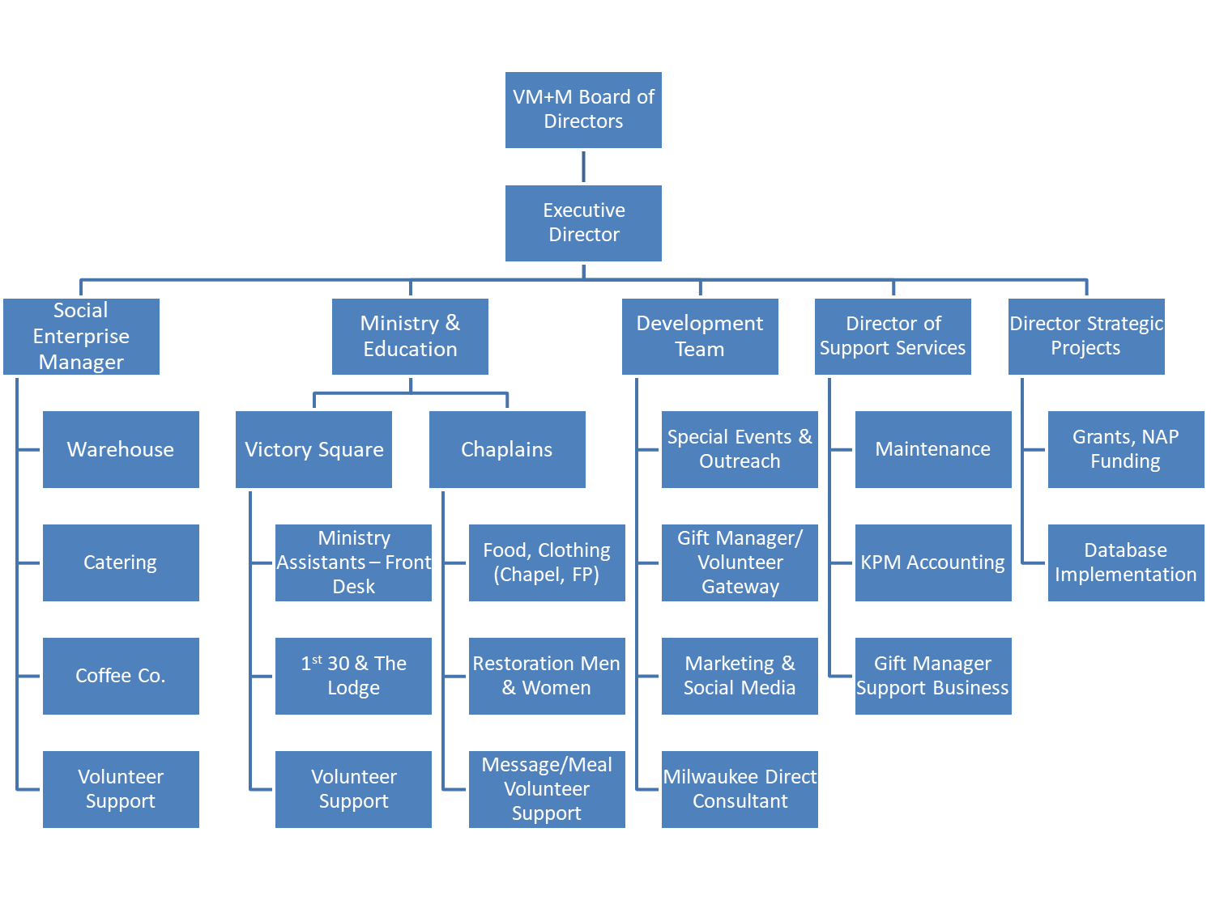

List of Key Staff Members and Contact Info

Coming…

Board of Directors Self-Evaluation Questions

- The board operates under a set of policies, procedures, and guidelines with which all members are familiar.

- The Executive Committee, reports to the board on all actions taken.

- Standing committees of the board meet regularly and report to the board.

- Board meetings are well attended, with near full turnout at each meeting.

- Nomination and appointment of board members follows a clear established procedure using a known process and criteria.

- Newly elected board members receive adequate orientation to their role and what is expected of them.

- Each board meeting includes an opportunity for learning about the organization’s activities.

- The board fully understands and is supportive of the strategic planning process of the ministry. (Decision making framework – share the gospel, revelation, reconciliation and restoration.)

- Board members receive meeting agendas and supporting materials in time for adequate advance review. (Executive Director report, financial report, key topic info)

Other Documents to be added

- Election of Board Members

- Election of Officers

- Process and timing of review of Policies & Procedures

